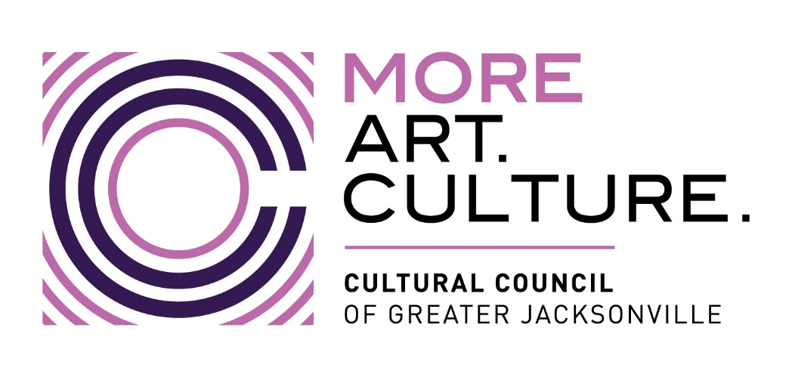

Minutes –
Cultural Council of Greater Jacksonville
CSGP FY25-26 Letter of Intent (LOI) Workshop / Help Session
VIRTUAL via Zoom
CCGJ Grants Team: Mary Pat Wallmeyer, Dannan Crabtree

Program Overview
- Cultural Service Grant Program (CSGP):
  - Provides public support to nonprofit organizations enhancing Jacksonville's cultural quality of life.
  - Funded by the City of Jacksonville, governed by Chapter 118, Part 6 of city ordinance.
  - General operating support only; capital expenses are not covered.

LOI Timeline
- LOI Deadline: Wednesday, February 26, 2025, at 11:59 p.m. (submitted via Foundant).
- Eligibility Notification: April 2025.
- Mandatory Application Workshop: For eligible applicants, to be held in April.
- Full Application Due: June 11, 2025 (exact date TBA).
- Grant Period: October 1, 2025 – September 30, 2026.

How to Access & Submit the LOI
- Use Foundant online system:
https://www.grantinterface.com/Home/Logon?urlkey=culturalcouncil
- Applicants must:
  - Create an account.
  - Click “Apply” on the dashboard.
  - Select and begin the FY2025 Cultural Service Grant Program LOI form.
  - Save, collaborate, and submit electronically.

LOI Sections & Requirements
- Sections in the LOI:
  - Eligibility Criteria
  - Grant Request & Match
  - Required Attachments
  - Signature Certification
- Required Documentation:
  - IRS 501(c)(3) Determination Letter
  - Corporate Charter / Articles of Incorporation
  - Sunbiz Annual Report
  - Three years of 990s
  - Board and staff demographic survey
  - Board of Directors list with affiliations
  - Bylaws (if applicable)
  - Charitable Solicitation Permit
  - Proof of city funding process (if receiving other COJ funds)
  - Description of non-discriminatory services and arts/culture mission

Eligibility Highlights
- Must operate in Duval County as a 501(c)(3) for at least 3 years.
- Board members must serve without compensation.
- Minimum 76% of operating revenue must come from sources other than the CSGP.
- Must provide arts/culture programming as primary mission.
- Must serve the general public on a non-discriminatory basis.

Grant Request Guidelines
- New Applicants:
  - Annual Budget < $250,000: Request up to $5,000
  - Annual Budget ≥ $250,000: Request up to $10,000
  - Minimum request amount is $5,000
  - Must demonstrate 3:1 cash match (i.e., CSGP may represent no more than 24% of revenues).

Final LOI Submission Requirements
- Upload completed Grant Request Worksheet in Foundant.
- Attach a current Charitable Solicitation Permit or exemption letter.
- Submit form with authorized electronic signature certifying accuracy and eligibility.

Questions and Support
- Applicants were encouraged to reach out for support: grants@culturalcouncil.org

