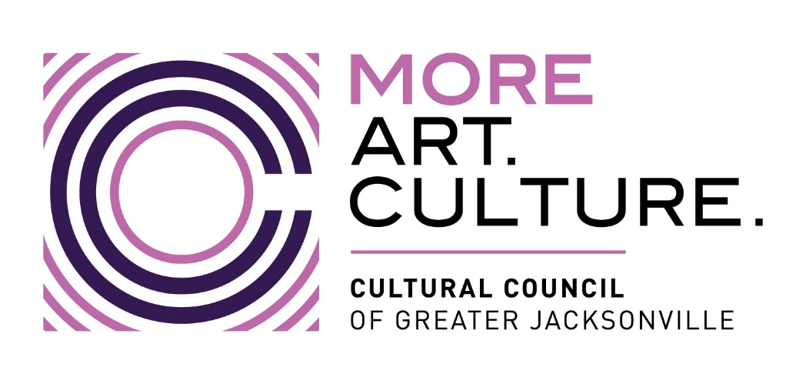

Minutes –
Cultural Council of Greater Jacksonville
FY 2024-2025 Combined Operating and Capital Compliance Workshop
Wednesday, November 20, 2024 9:00 a.m.
VIRTUAL via Zoom
CCGJ Grants Team: Mary Pat Wallmeyer, Dannan Crabtree, Sarah Chau
Org. Representatives in Attendance: Cathedral Arts Project, DH Cummer Museum, Florida Theatre, Jacksonville Symphony, Museum of Contemporary Art, The Florida Ballet, WJCT, Art with a Heart in Healthcare, Beaches Fine Art Series, Beaches Museum, Don’t Miss A Beat, Jacksonville Arts & Music School, Jacksonville Historical Society, Players By The Sea, Springfield Preservation & Revitalization Council, The Jacksonville Children’s Chorus, Theatre Jacksonville, All Beaches Experimental Theatre, Hope at Hand, Jacksonville Dance Theatre, Mandarin Museum, The 5 & Dime, The Art Center Cooperative, Norman Studios, Stage Aurora
1. Welcome and Housekeeping
- Participants reminded to mute microphones.
- Workshop materials (slides, guidelines, timelines, FAQs, ordinance) are available in Foundant's Shared Documents.
- All questions should be sent to: grants@culturalcouncil.org.

2. Cultural Service Grant Program (CSGP) Overview
- Purpose: Provide public support for arts and culture nonprofits in Jacksonville.
- Eligibility: 501(c)(3) orgs operating in Duval County with a primary mission in arts/culture.
- Funding: General operating and capital improvements, administered under Chapter 118 of the City ordinance.

3. Operating Grant Details
- Disbursement Schedule:
  - 1st Payment: Dec 2024 / Jan 2025
  - 2nd Payment: Mid-February 2025
  - 3rd Payment: Mid-May 2025
  - 4th Payment: Mid-August 2025
- Requirements:
  - Direct Deposit Authorization required for new grantees/bank changes.
  - New backup documentation standards: No longer accepting General Ledgers alone.
    - Proof required for payroll, vendor payments, salaries, etc.
  - Updated audit supplemental schedules must be submitted.
- Important Due Dates:
  - Budget Forms A & B, Q1 Reports C & D, Satisfaction Surveys: Jan 31, 2025
  - Capital Grant Application: Feb 7, 2025
  - ROI Surveys (returning grantees): Feb 13, 2025
  - Operating Grant LOI: Feb 26, 2025
  - LOI Workshop: Jan 30, 2025
  - Capital Grant Hearings: Apr 2, 2025
  - CCGJ Board Meeting: Apr 24, 2025
  - Operating Grant Application Deadline: Jun 11, 2025
  - Operating Grant Hearings: Oct 1, 2025

4. Compliance Highlights
- Segregated Bank Account Required: All payments and reimbursements must be managed through a separate account.
- Audit Requirements (based on total COJ funding):
  - <$100k: Certified annual report
  - $100k–$500k: GAAS audit
  - $500k: GAAS + GAS audit

5. Capital Grant Overview
- Application Deadline: Feb 7, 2025
- Purpose: Reimbursement for renovations, construction, or acquisition of cultural facilities.
- Covered Period: Oct 1, 2024 – Sept 15, 2025
- Eligibility: Must be an FY25 Operating Grant recipient in good standing with matching funds by Sept 30, 2025.
- Allowable Projects:
  - Renovation, construction, acquisition of ADA-compliant cultural facilities in Duval County.
  - Cash match required 1:1, in-kind not accepted.
- Request Range:
  - Max: $100,000
  - No minimum

6. Capital Grant Application Process
- Foundant Access
- Required Forms:
  - Capital Project Budget
  - Expense and Match Documentation
- Scoring & Review:
  - Evaluated by CSGP Committee; minimum score 70 to qualify.
  - Awards approved by CCGJ Board: April 24, 2025

7. Capital Grant Reporting Deadlines
- Revised Budget Due: May 15, 2025
- Monthly Reimbursement Requests: Due the 15th of each month (May–Sept)
- Final Reports Due: Oct 17, 2025
  - Form E2, proof of match, bank statement, narrative, 5-year record retention
  - Audit required for funding over $100k
- Restrictive Covenant (Awards >$25k):
  - Due Oct 17, 2025
  - Must certify facility’s use for cultural purposes for at least 10 years

8. Acknowledgment and Branding
- Required statement for all funded projects:
“This project is funded in part by the City of Jacksonville through the Cultural Council of Greater Jacksonville’s Cultural Service Capital Program.”
- Use of the Cultural Council’s new logo is mandatory.

Closing Remarks:
- Questions should be emailed to grants@culturalcouncil.org
- Grantees are encouraged to maintain communication throughout the grant cycle.

