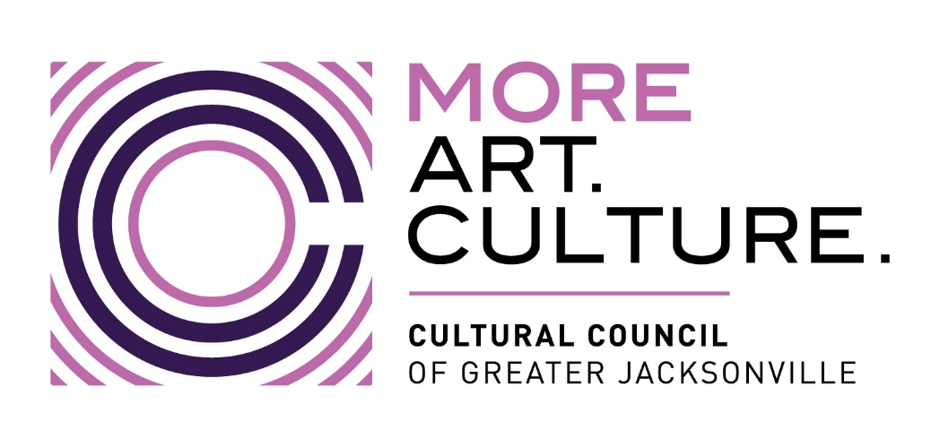

Minutes –
Cultural Council of Greater Jacksonville
Individual Artist Grant Pilot Program Coaches & Artist Meeting
Wednesday, November 20, 2024 9:00 a.m.
Room 208, Jessie Ball duPont Center (40 E. Adams St., Jax 32202)

Facilitators / Presenters
- Mary Pay Wallmeyer
- Dannan Crabtree
- Allison Galloway Gonzalez
- Sarah Chau

Part 1: Coaches Meeting (9:00 AM- 10:00 AM)
Attendees:
- Yvette Hyater-Adams
- Kristen Sullivan
- Liz McCoy
- Matt Shaw
Discussion Highlights:
- Distribution of cohort assignments to each coach.
- Overview of administrative processes:
  - Invoice submission
  - Monthly reporting requirements
- Coaching Overview Presentation by Yvette Hyater-Adams:
  - Philosophy and approach to coaching artists
  - Best practices for relationship-building and supporting grantees through the pilot program

Part 2: Grantee Meeting (10:00 AM – 11:00 AM)
Topics Covered:
Program Overview:
- Grant guidelines and goals of the pilot
- Timeline of grant activities and key deadlines
Budget Guidance:
- Allowable expenses
- How to submit revised budgets for approval
Payment & Contracts:
- Step-by-step on setting up Gusto accounts to receive payments
- Signing and returning grant contracts
Reporting & Communication:
- Monthly reporting expectations and due dates
- Introduction to SharePoint folder system
- Use of the Foundant grantmaking platform

Next Steps
- Coaches begin engaging with their assigned grantees
- Grantees complete contract signing and payment setup
- Monthly reporting begins according to timeline provided
- Ongoing support through SharePoint and Foundant systems

