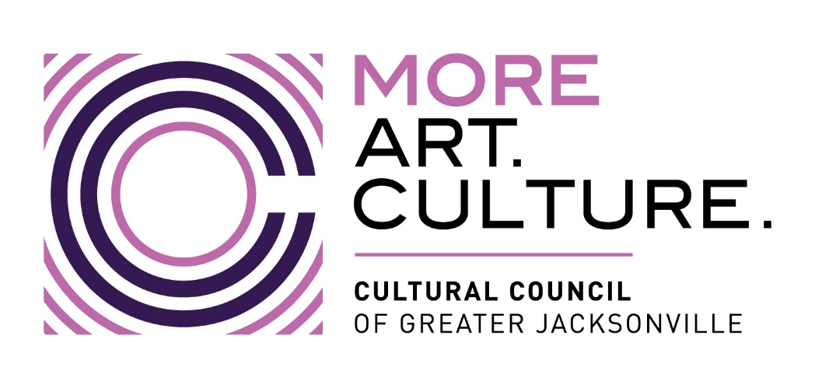

Minutes –
Cultural Council of Greater Jacksonville
Individual Artist Grant Pilot Program Panel Meeting
Wednesday, October 16th, 2024 11:30 a.m.
Room 201, Jessie Ball duPont Center (40 E. Adams St., Jax 32202)

Present: Darrin Eakins (virtual), Adam Madrid, Suzanne Pickett, Alma Ramirez, Chrys Yates
Staff: Sarah Chau, Dannan Crabtree, Mary Pat Wallmeyer, Allison Galloway-Gonzalez (virtual)
Absent: Michael Freed, Jason Peoples

Welcome & Introductions Mary Pat Wallmeyer

Overview – Application review Mary Pat Wallmeyer
- Panel shared comments on review process
- Suggestions for process improvements

Applicant Demographics Sarah Chau
- 300 applications received, 252 eligible
- Applicants from 26 area codes
- Majority of applicants in visual arts, age range 25-44, Bachelor’s Degree

Certification of Panel Scores Mary Pat Wallmeyer
- Motion to certify scores made and approved by Panel

Opportunity for Public Comment Mary Pat Wallmeyer
- Andrew Pollock

Adjournment Mary Pat Wallmeyer

