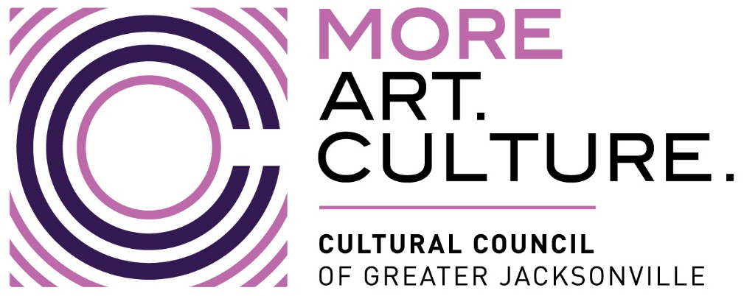
PUBLIC NOTICE
23-24 Cultural Service Grant Program Committee: Appreciation Mixer
IN-PERSON MEETING NOTICE
Notice is hereby given that the Cultural Service Grant Program Committee will meet in an in-person meeting on Thursday, November 30, 2023, at 4:30 PM. The public is invited to attend in-person at The Jessie Ball duPont Center at 40 East Adams Street, in the Rooftop Garden (Third Floor.)
This gathering is an end-of-year celebration with the CSGP Committee and the Cultural Council of Greater Jacksonville Board of Directors, with invitations extended to elected officials. This notice is provided in the interest of transparency; there will be no action or public comment taken.
Pursuant to the American with Disabilities Act, accommodations for persons with disabilities are available upon request. Please allow 1-2 business days notification to process; last minute requests will be accepted, but may not be possible to fulfill. Please contact Disabled Services Division at: V(904) 255-5466, TTY(904) 255-5476, or email your request to karat@coj.net.
Please contact John Poage, by telephone at (904) 944-3609 or by email at John@culturalcouncil.org if you have any questions regarding this notice.

