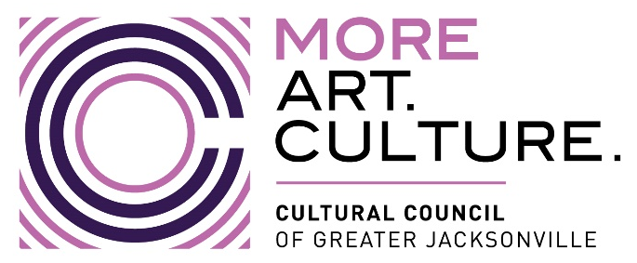
Cultural Council of Greater Jacksonville Finance Committee
Meeting MINUTES
IN PERSON Meeting
Thursday, October 12, 2023 4:00 – 5:00 PM ET, {Publicly Noticed}
□ Lisa Johnson, Interim Committee Chair □ Chris Lazzara, Committee Member
□ Ashley Folladori, Committee Member □ Tim Snyder, Committee Member
□ Ari Jolly, Board Chair
A. Welcome, Attendance, & Call to Order 4:00PM
The meeting was called to order at 4:00pm by Interim Finance Committee Chair Johnson. Also present were Director Folladori and Director Snyder.
B. Action Item: Voting- Review and Approval of Minutes
1. Minutes from August 11, 2023 Finance Committee Meeting 4:03-4:05 PM
Motion: “Move to approve minutes of the 8/11/23 Cultural Council Finance Committee meeting as written.”
The motion was so moved and the minutes were approved with no changes

C. Fiscal Year 2024 CSGP Award Allocations – Amy Palmer 4:05-4:15 PM
Amy Palmer provided a review of the methodology used to determine the FY2024 CSGP Award Allocations. The methodology will require a revision to the cap used in previous years as the amount of the Grant from the City increased significantly. She further explained the methodology required to determine the Capital Grant awards as is included in the Draft Budget.

D. Financial Review for FY2023 and Draft Budget
-Diana Donovan and Nan Kreamer 4:15-4:50 PM
Diana and Nan provided a review of the financial results for Fiscal Year 2023 which just ended in September. Overall, the objectives of the organization were met successfully and the staff is looking forward to the year ahead. Further, Diana and Nan introduced the plans for Fiscal Year 2024 including the proposed budget. Discussion ensued in review of both the revenue opportunities, fundraising efforts and operating expenses. After a thorough discussion, the committee members acknowledged they were prepared to move forward and recommend the Budget as presented to the full Board at its next meeting.

E. Action Item: Voting- Recommend the adoption of the FY2024 to the full Board of Directors
Motion: “Move to recommend the FY2024 Budget be approved by the full Board of Directors meeting scheduled for October 19, 2023.”
The motion was so moved, seconded and all agreed to move recommend that the full Board approve the budget for Fiscal Year 2024 as presented.

E. Public Comment 4:50-4:55 PM
There was no public comment at this meeting.

Adjourn 5:00 PM
There being no further business, the meeting was adjourned at 5:00PM.

