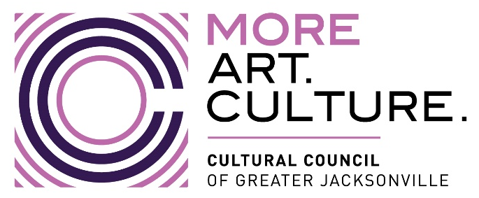
Cultural Council of Greater Jacksonville Finance Committee
Meeting Agenda
IN PERSON Meeting
Jessie Ball duPont Center Room 202, 40 E Adams St, Jacksonville, FL 32202
Thursday, October 12, 2023 4:00 – 5:00 PM ET, {Publicly Noticed}
Zoom Meeting Link: https://us06web.zoom.us/j/84437139884
Phone Number: +1 646 558 8656 US Meeting ID: 844 3713 9884
□ Lisa Johnson, Interim Committee Chair □ Chris Lazzara, Committee Member
□ Ashley Folladori, Committee Member □ Tim Snyder, Committee Member
□ Ari Jolly, Board Chair

A. Welcome, Attendance, & Call to Order 4:00PM

B. Action Item: Voting- Review and Approval of Minutes

1. Minutes from August 11, 2023 Finance Committee Meeting 4:03-4:05 PM
Motion: “Move to approve minutes of the 8/11/23 Cultural Council Finance Committee meeting as written.”

C. Fiscal Year 2024 CSGP Award Allocations – Amy Palmer 4:05-4:15 PM

D. Financial Review for FY2023 and Draft Budget
-Diana Donovan and Nan Kreamer 4:15-4:50 PM

E. Action Item: Voting- Recommend the adoption of the FY2024 to the full Board of Directors
Motion: “Move to recommend the FY2024 Budget be approved by the full Board of Directors meeting scheduled for October 19, 2023.”

E. Public Comment 4:50-4:55 PM

Adjourn 5:00 PM

